Source code

/*

* To change this license header, choose License Headers in Project Properties.

* To change this template file, choose Tools | Templates

* and open the template in the editor.

*/

package main;

import java.util.*;

public class Main {

public static void main(String[] args) {

Scanner read = new Scanner(System.in);

System.out.print("enter your name : ");

String name = read.nextLine();

System.out.println("Uppercase : " + name.toUpperCase());

System.out.println("Lowercase : " + name.toLowerCase());

System.out.println("Your name in half : " + name.substring(0,1) + "" + name.substring(1, 3));

System.out.println("your name length : " + name.length());

System.out.println("your lucky number : " + (int) (Math.random() * 100));

System.out.println("=======================================");{

String str = "izzaaq";

int counter = 0;

for (int i = 0; i < str.length() - 1; i++) {

if (str.charAt(i) == 'a'){

counter++;

}

}

System.out.println("your name : " + str);

System.out.println("get character 'a' : " + counter);

}

}

}

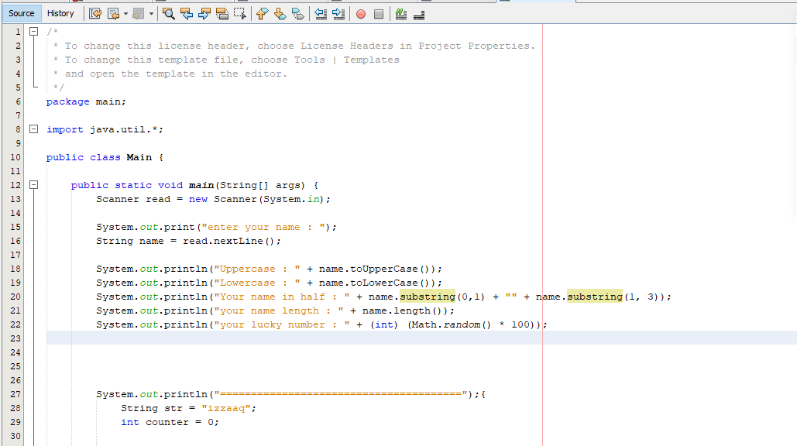

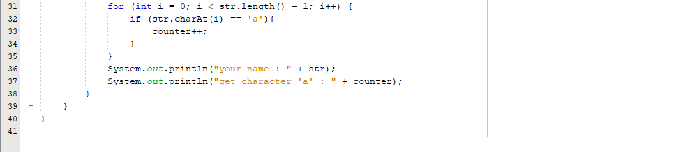

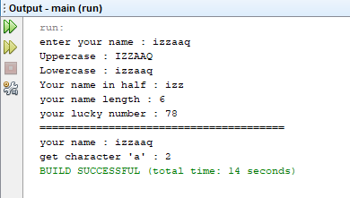

|  |
| --- |
| Tealive |
| -menu : String  -order : String  -seatNumber : String |

|  |
| --- |
| Cafe |
| -menu : String  -order : String  -seatNumber : String |

|  |
| --- |
| Coffee |
| -menu : String  -order : String  -seatNumber : String |

